**Predicting Housing Prices Using Regression Techniques**

Gowthami Chebrolu1, Anuradha Ebushi1, Samira Ghazvineh1, Mahesh K Maddineni1, Jennifer Retzloff1, Nisha Thakur1, Bhargavi Tipirineni1

1Indiana University-Purdue University, Indianapolis, IN 46202, USA,

gchebro@iu.edu, aebushi@iu.edu, sghazvin@iu.edu, mmaddine@iu.edu, jemretz@iu.edu, nithakur@iu.edu, btipirin@iu.edu

**Abstract.** This project analyzes the amenities and features that most influence the cost of Rent in India. This project aims to accurately predict the price of Rent given a specific list of features to aid the renter in making a budget-friendly choice. Using various techniques to analyze the data, we constructed a list of the most influential factors for consideration when house shopping. As the cost of living continues to climb, we want to provide the consumer with the appropriate data to make a well-educated decision about one of life's most basic necessities – housing.

**Keywords:** India, Mumbai, New Delhi, Kolkata, Rent, Housing, Cost of Living, Affordable Living, BHK, Average Rent Budget, Tenant Preferred, Data Analysis, Data Visualization, Multivariate Linear Regression, Logistic Regression, Python

1. **Project Scope**

**1.1 Introduction**

Housing costs have become burdensome with record-high inflation and rising interest rates [2]. Renters are looking to save money wherever they can. Many factors affect the price of a home. Variables include City, country, location, size, floor, tax laws, house type, number of bathrooms, furnished/unfurnished homes, and supply. Using the "House Rent Prediction" dataset (https://www.kaggle.com/datasets/iamsouravbanerjee/house-rent-prediction-dataset) recently published on Kaggle, we will examine trends to predict which variables most affect rental prices in India [1]. Data quality is critical for predicting price changes in the housing market. Regression analysis is frequently used in statistical analysis to estimate relationships between various variables.

**1.2 Aim**

This project aims to predict house rent based on variables in the "House Rent Prediction Dataset" (i.e., size, level, furnishing, location, tenant preferred, and the number of bathrooms) by using regression algorithms in machine learning.

**1.3 Purpose**

The purpose of this study is to better understand which factors influence the price of rental housing in India. With nearly one-third of the population renting, individuals want the biggest "bang for their buck" [3]. Given the competitive nature of the rental market, renters are willing to pay more for specific factors (i.e., location, view of the house, number of bedrooms, hall, kitchen, size of the property, the floor of the house, area type, area locality, City, furnishing status of the house, etc.) [4]. The question is, "How much more?" The group will use the above-referenced dataset to build a model to predict rental price points based on these types of factors, precisely the number of BHK (d), size (e), area type (x), and location (z). This model will help consumers budget accordingly to secure the desired factors in a new home.

1. **Methodology**

**2.1 Steps of the Project**

The purpose of this project is to predict house rent based on variables in the "House Rent Prediction Dataset" (i.e., size, level, furnishing, location, tenant preferred, and the number of bathrooms) by using regression algorithms in machine learning, we hope to better understand which factors influence the price of rental housing in India.

The methodology of our project involves seven stages, which will be explained in more depth later in the report.

1. Data Collection
2. Data Extraction and Storage
3. Data Analysis
4. Data Visualization
5. Statistical Testing
6. Model Development and Evaluation.

**2.2 Original Team Members and Responsibilities**

Our team has a diverse set of skills and backgrounds. Below is the original list of team members we had for the project and the responsibilities we agreed on at the beginning of the project.

|  |  |  |
| --- | --- | --- |
| **Name of Team Member** | **Background** | **Work responsible** |
| Gowthami Chebrolu | BDS  New to SQL and Python | Perform data cleaning and data modification, create data visualization normality test |
| Anuradha Ebushi | BDS  New to Python and SQL | Create data visualization and normality test results using Python Seaborn and Matplotlib (seaborn pair plots, histogram), Presentation work |
| Samira Ghazvineh | B.S. in physical education M.S in business administration  Experience with SQL  New to Python | Create data visualization normality test results using Python Seaborn and Matplotlib results using Python Seaborn and Matplotlib (seaborn pair plot), Presentation work |
| Mahesh Kumar | B.S. Agricultural Sciences (Honors) | Conduct multiple linear regression model with different factors |
| Bhargavi Tipirineni | BDS  Experience in SQL and Python | Conduct multiple linear regression model with different factors |
| Nisha Thakur | Background in pharmacy Masters in MBA (Sales and Marketing)  New to SQL and Python. | Conduct multiple linear regression model with different factors, document work |
| Jennifer Retzloff | B.S. Health Information Management (Honors) RHIA certified  EPIC build certified New to SQL and Python | Perform ANOVA test using Python to test the accuracy of the above three models, analyze the best fit model for rent prediction, document work |

**Fig. 1.** Original Responsibilities of Team Members for this Project

**2.3 Actual Contributions from Individual Team Members**

We initially did a good job of breaking up responsibilities to work as efficiently as possible. However, the above table was not wholly representative of the duties of each team member due to unforeseen changes, as well as a better understanding of what strengths were of each team member

|  |  |
| --- | --- |
| **Name of Team Member** | **Work responsible** |
| Nisha Thakur | Perform data cleaning and data modification, create data visualization normality test |
| Gowthami Chebrolu/Anuradha Ebushi | Create data visualization normality test results using Python Seaborn and Matplotlib (seaborn pair plots, histogram), Presentation work |
| Samira Ghazvineh | Create data visualization normality test results using Python Seaborn and Matplotlib results using Python Seaborn and Matplotlib (seaborn pair plot), Presentation work |
| Nisha Thakur/Mahesh Kumar | Conduct multiple linear regression model with different factors |
| Nisha Thakur/Bhargavi Tipirineni | Conduct multiple linear regression model with different factors |
| Nisha Thakur | Conduct multiple linear regression model with different factors, Perform model evaluation using R-squared, document work |
| Jennifer Retzloff | Perform ANOVA test and Hypothesis test, Develop Logistic Regression model, Evaluate model using accuracy score, document work, build the presentation |

**Fig. 2.** Revised Responsibilities of Team Members for this Project

**2.4 Project Challenges**

The main difficulties came from the fact that everyone had varied preferences based on their class schedules and other topic deadlines and that meetings were held online. Therefore, for students working remotely, we connected through Zoom, and if necessary, we would meet in person at the library to discuss the project.

Outliners posed a problem. We cleaned the dataset, found the null values, and removed the duplicate values. However, we missed the outliers when creating scatter plots, boxplots, and bar graphs. The visuals lacked clarity. After finding the outliers, we eliminated the +2SD and -2SD outliers, as most of the data (96%) lies between the +2 and -2SD.

Our team had trouble appropriately coding the ANOVA test. We got an error saying the BHK data was "not a number" because the code contained a colon. In order to resolve this issue, corrections were performed.

Given that the accuracy of the multiple regression model was poor, it did not perform well. We also tried utilizing a different regression model, the logistic regression model, but it again didn't work out well. We found that the dataset we used lacked resolution.

1. **Data Collection**

A CSV file containing the housing rent dataset was downloaded from Kaggle <https://www.kaggle.com/datasets/iamsouravbanerjee/house-rent-prediction-dataset> . The Jupyter Notebook was filled with the dataset. We investigated the data using Python and many packages, including Pandas, Matplotlib, Sklearn, and Numpy. The "Files" tab on our group page in Canvas was where files were kept. A total of 12 columns and 4746 rows make up the House Rent Prediction dataset. The house rental dataset contains the following variables:

* BHK
* Rent
* Size
* Number of Floors
* Area Type
* Area Locality
* City
* Furnishing Status
* Type of Tenant Preferred
* Number of Bathrooms
* Point of Contact.

1. **Data Extraction and Storage**

**4.1 Data Extraction**

We began by extracting data from Kaggle.com as the first stage in the data extraction process. We examined every factor affecting the Rent estimation and discovered that the dataset offers comprehensive data on the Indian rental housing market. More than 4000 homes are listed in the collection. Our project's primary goal is to "predict home prices using regression techniques." We anticipate that factors such as size, floor plan, number of bathrooms, tenant preferences, location, country, house style, and whether a home is furnished or unfurnished will affect Rent.

**Description of variables:**

* **Size:** The square feet of the house affecting the Rent.
* **Location:** We are speculating as to where the maximum Rent will be because India has many distinct cities.
* **The number of bathrooms:** Since we are estimating the Rent, we also assume that the number of bathrooms is related to the Rent.
* **Furnished/unfurnished homes:** We estimate that Indians will favor either furnished or unfurnished residences.
* **Floor:** We anticipate that the floor will also help estimate the Rent, as we can verify whether the first and second floors are more expensive on the ground floor.

**4.2 Data Import and Cleaning**

Data cleaning was done following data extraction. The process of cleaning data is crucial since it helps to spot outliers, duplicate values, and null values. Since our dataset contains more than 4000 residences, we cleaned the data for it. As a part of data cleaning, we imported the data into Python. We have imported the house rent dataset CSV file using pandas and read the file.import pandas as pd.

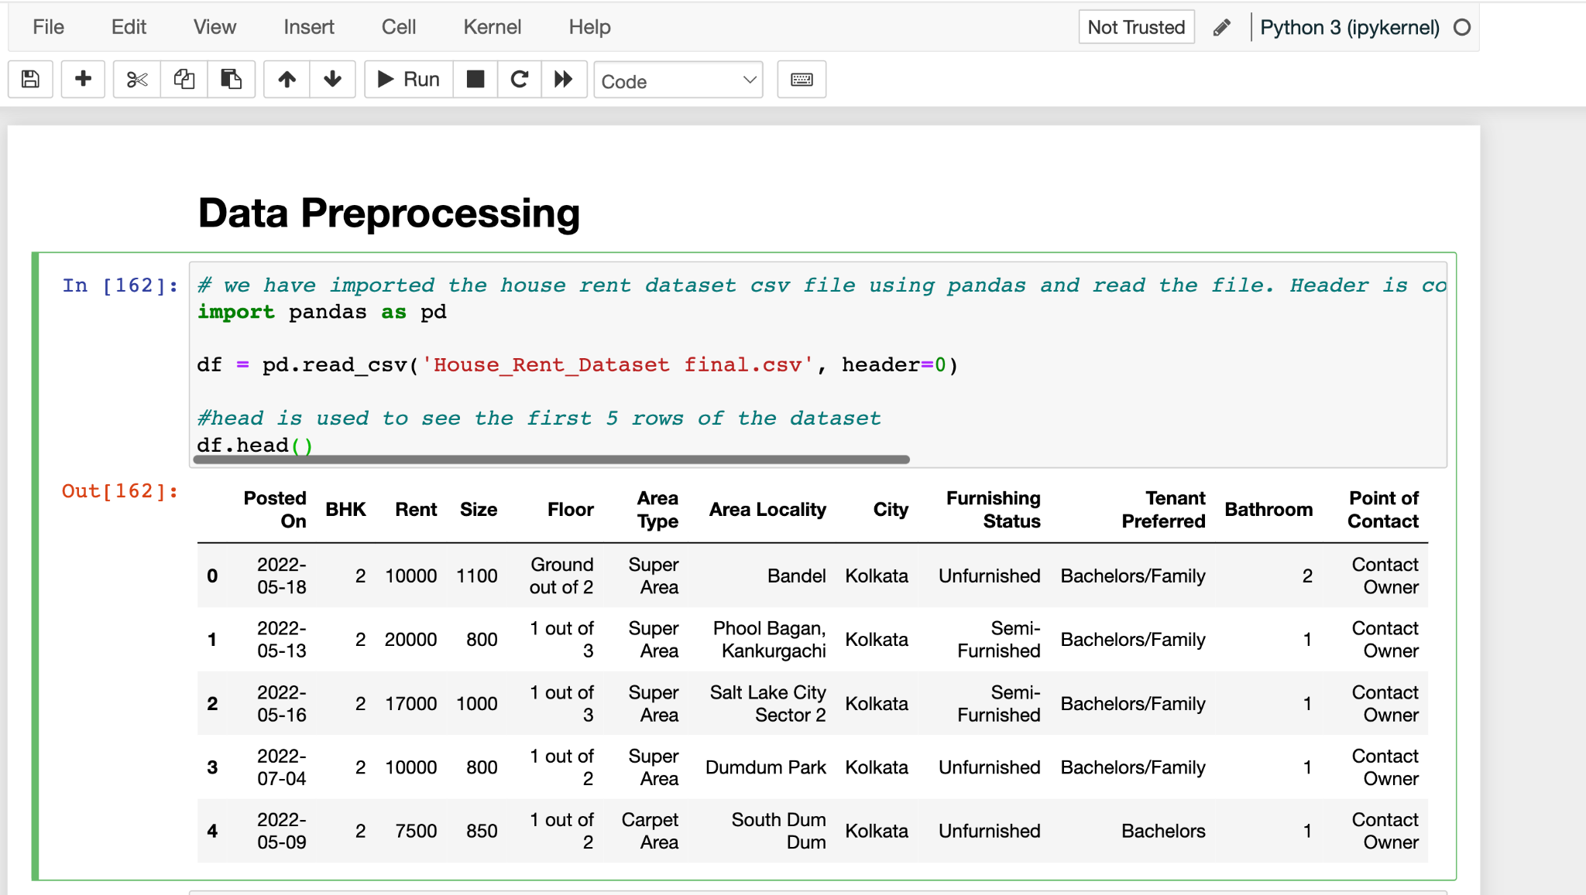

**Fig. 3.** Import data into Python

We used df.shape, which displays the precise number of rows and columns, to get the exact number of rows and columns, and we learned that there are 4746 rows and 12 columns.

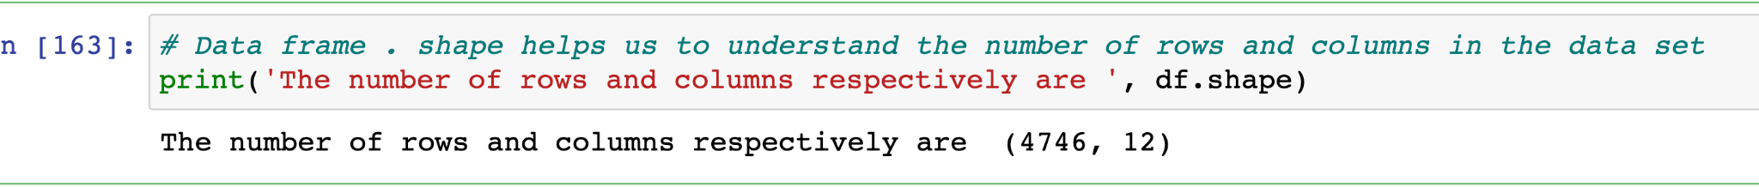

**Fig. 4.** Code used to determine the shape of the data

We used df.info(), which provides information about the variable's datatype. The data type of each variable is explained in detail by the df.info() function.

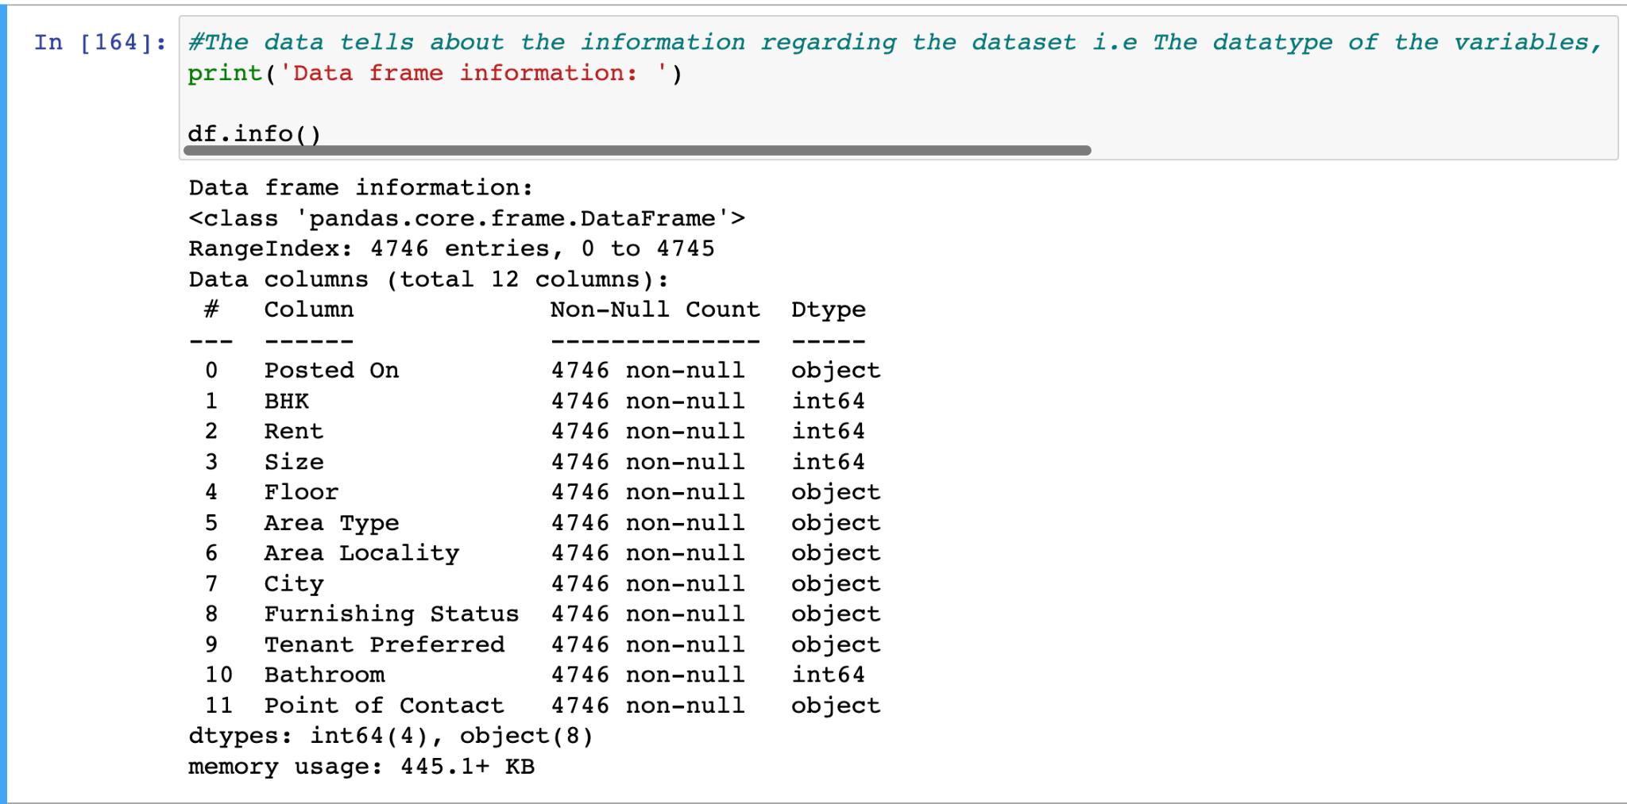

**Fig. 5.** Code used to determine the datatype of each variable

We used the df.explain function to describe the data frame (). In the df. description, "BHK" stands for "one bedroom, one bathroom, and kitchen," and "bathroom" refers to the number of bathrooms in the home.

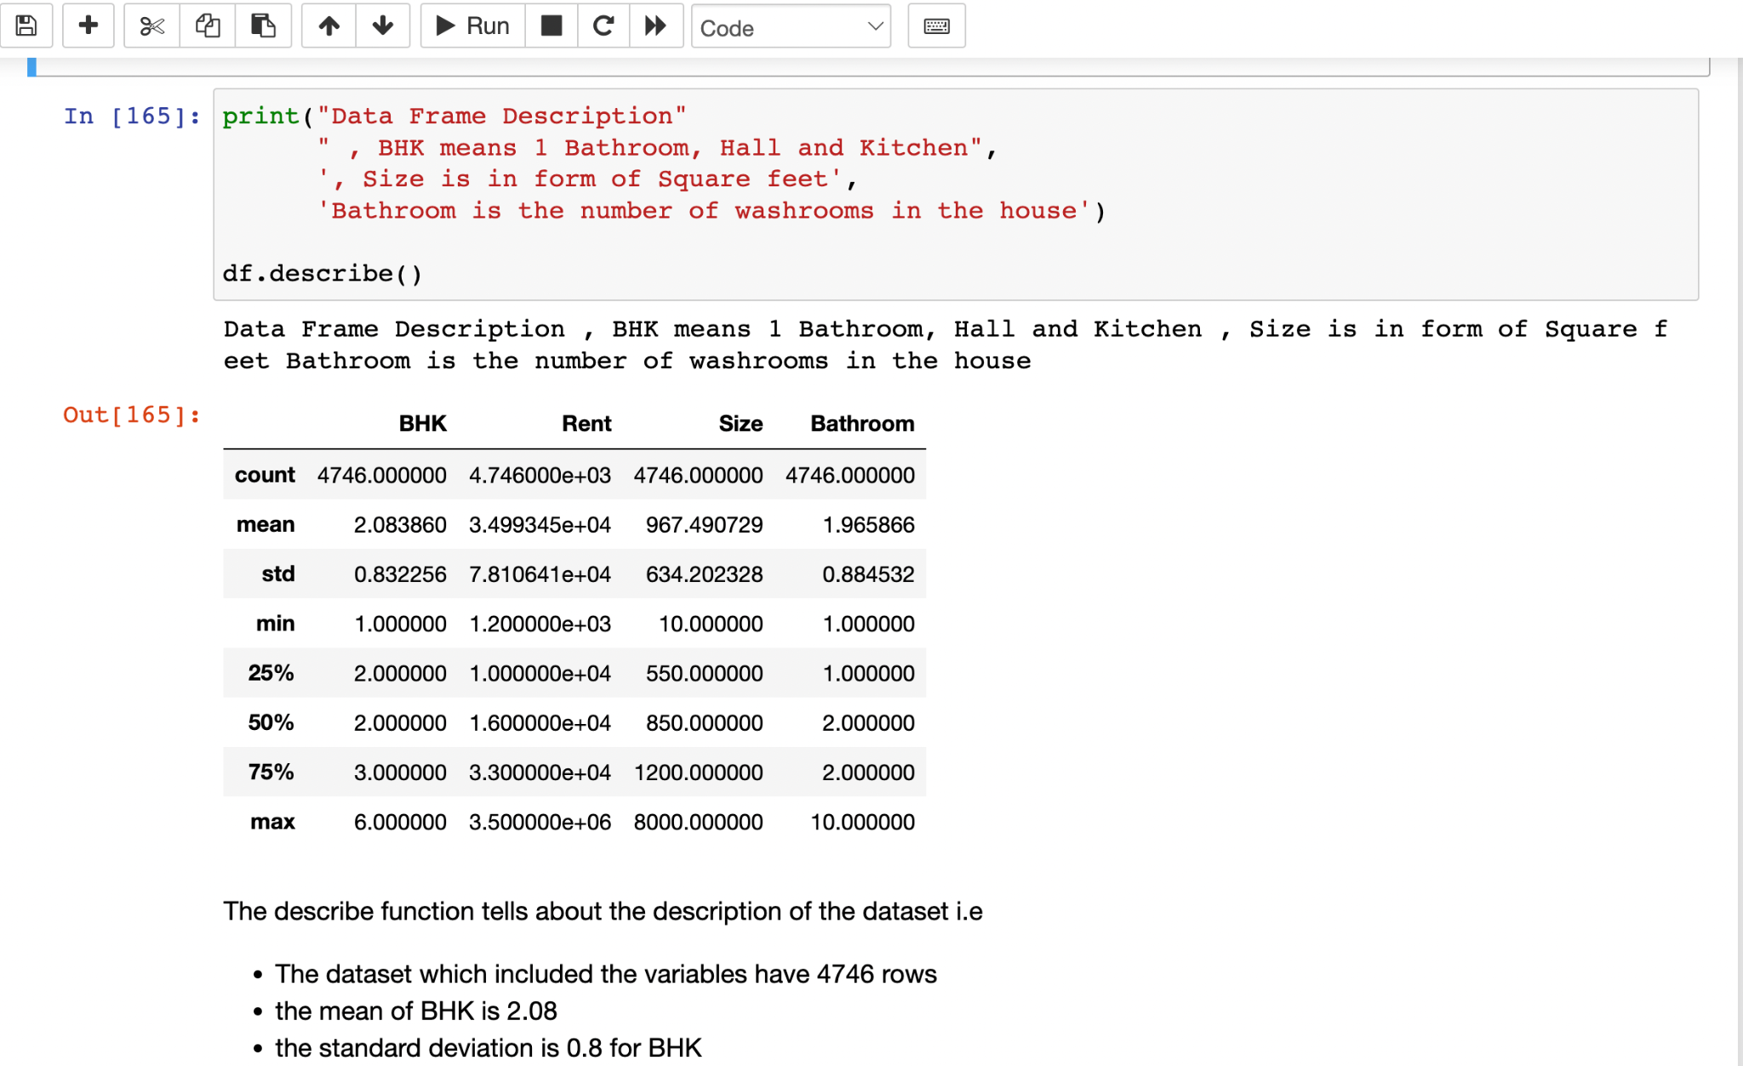

**Fig. 6.** Provides the statistical data associated with each variable

The dataset and the variables are described in detail by df.describe(). The mean and standard deviation for BHK are 2.08 and 0.8, respectively. The BHK has a minimum of 1 and a maximum of 6 rooms (bathroom, hall, and kitchen).

The next step we did was checking for any missing values and any null values. We used the code df.isnull(). The output return is in Boolean type. The Boolean type says in true or false statement. True means there are null values or missing values. False means there are no null values or missing values. After using the code df.isnull(), we learned that our dataset does not contain any null or missing values.

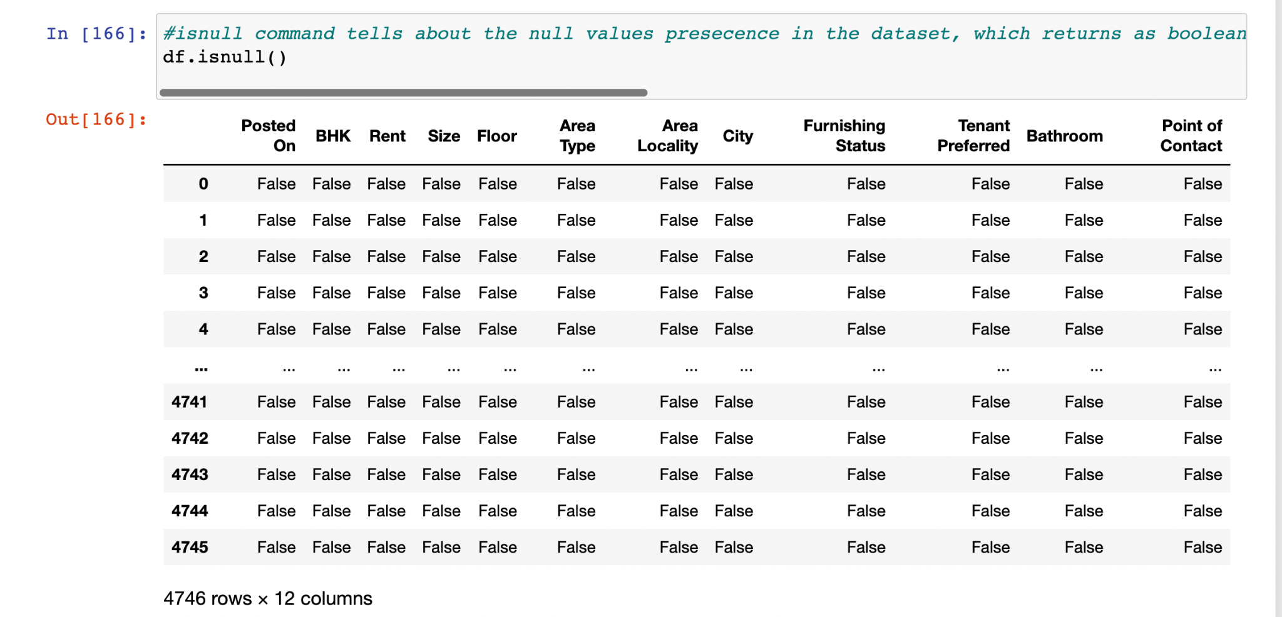

**Fig. 7** Code used to check for missing or null values

We used df.isnull().sum() to generate the final output of variables with no missing or null values.

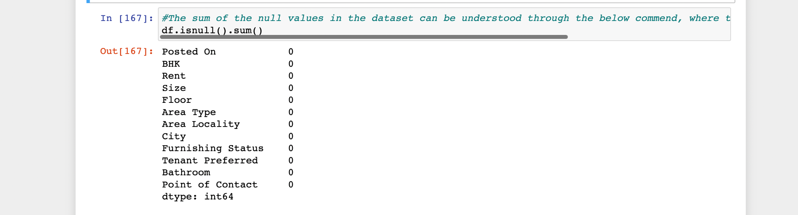

**Fig. 8** Output of df.isnull().sum() function

After examining the missing and null entries, we used df.duplicated() to see if our dataset had any duplicated values. Here, the output of this command is a boolean value (true/false). Because there are no duplicate values in our data collection, there are no duplicate values in the output.

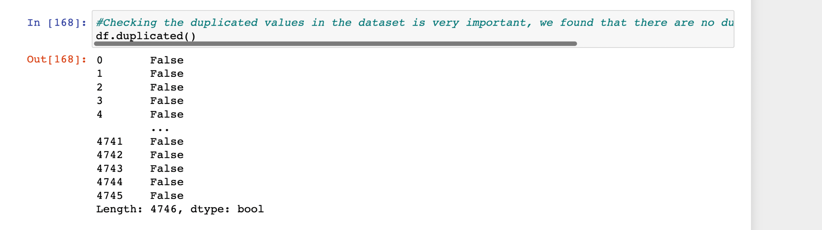

**Fig. 9** Output of df.duplicated() function – used to remove duplicate records.

After checking for missing values and duplicated values, we came to know that there are no missing and duplicated values in our dataset. We import the library seaborn and use matplot lib and box plot. We checked for outliers.

By visualizing data variability, the Box and Whisker plot enables us to identify outliers in the dataset. For the model's efficiency to increase, we removed outliers from the Rent column.

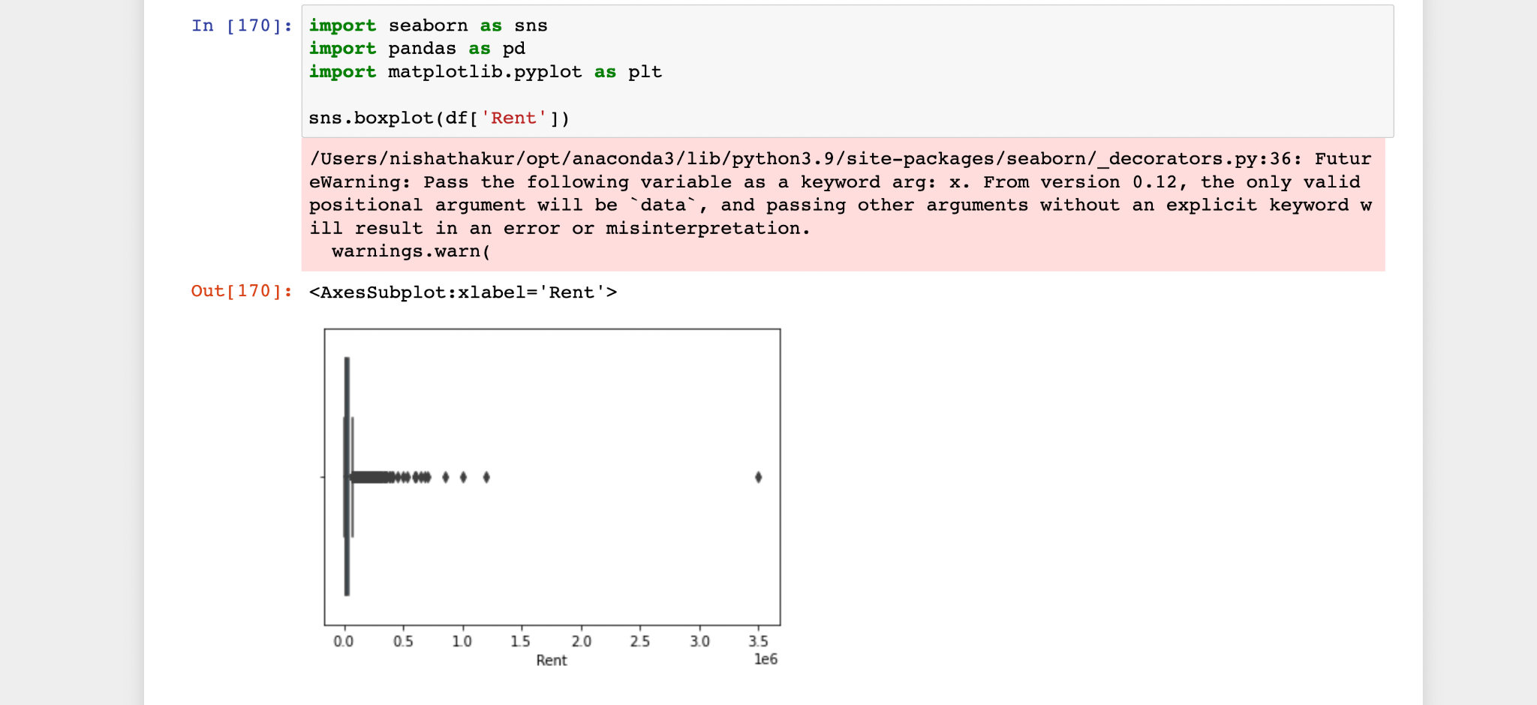

**Fig. 8** Box and Whisker plot of the "Rent" variable before removing outliers

We removed outliers because they are misleading, which will decrease the model's performance.

In the above diagrams, the outliers are marked as diamond shape points. Using 25th, 50th, and 75th percentiles, a boxplot provides an overview of a sample of data. The lower, median and upper quartiles of these percentiles are also known by these names. A box plot shows groups of numerical data by their quartiles in a visual manner. Detecting outliers in the data collection is another purpose for the boxplot. With just a box and whiskers, it effectively summarizes the data, enabling us to easily compare data between groups.

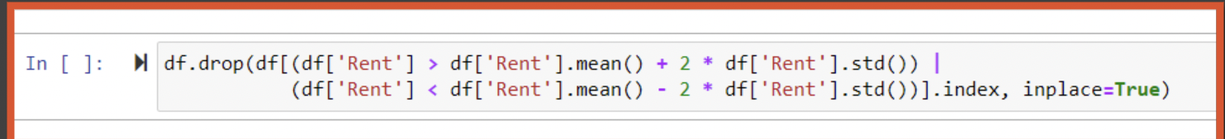

**Fig. 9** Removed outliers two standard deviations from the mean

The "Rent" variable ranged from 1,200 to 3,500,00. The data was significantly skewed. We used the above code to remove the outliers in the rent section. We reduced the number of rows from 4,746 to 4,632. We used df.shape() to confirm the rows had been removed

df.drop(df[(df['Rent'] > df['Rent'].mean() + 2 * df['Rent'].std()) | (df['Rent'] < df['Rent'].mean() - 2 * df['Rent'].std())].index, inplace=True)



**Fig. 10** Demonstrates the new size of the data set

**Box and whiskers plot:**

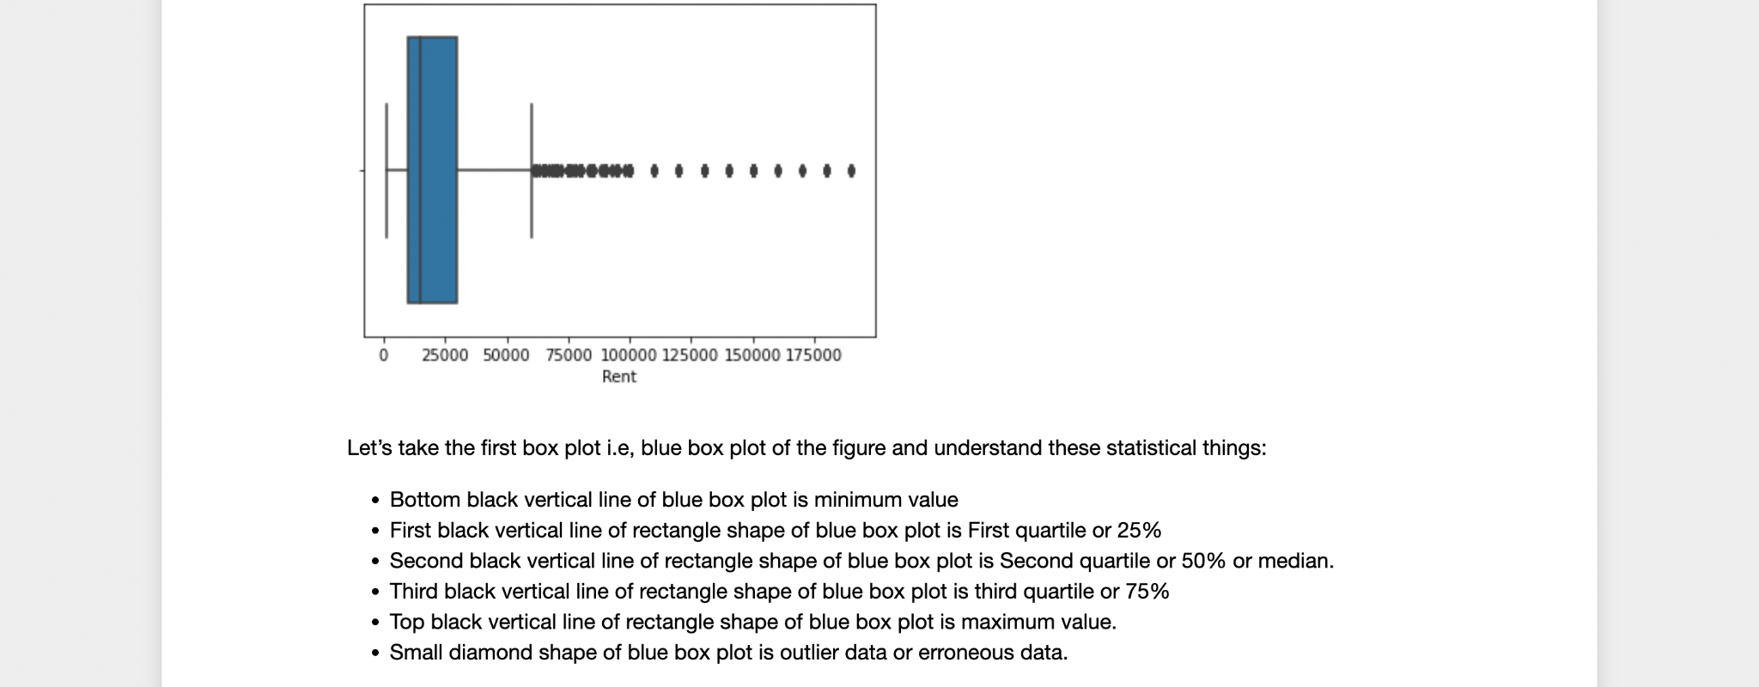

**Fig. 11** Box and whisker plot of the variable "Rent"

We followed the same methodology to remove extreme outliers from the "Size" variable, reducing the number of rows to 3,671.

After removing the outliers, we categorized several variables by replacing the string text with an integer. We used the df.replace to accomplish this task. We have given the variables the values 0, 1, 2,... to transform the object into an integer.

We replaced the Bachelors/Family-0, Bachelors-1, Family-2, Super area-0, Carpet area - 1, Built area-2, Contact owner-0, Contact agent- 1, Contact builder -2, Unfurnished -0, Semi-Furnished-1, Furnished-2, Kolkata-0, Mumbai-1, Bangalore- 2, Delhi-3, Chennai -4, and Hyderabad-5.

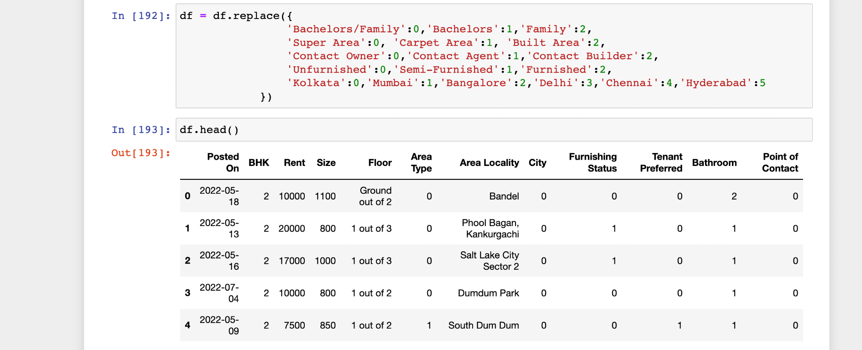

**Fig. 12** Variables containing string text were categorized

We split the Floor into the Floor level and Total Floor using the following code:

df['Total_Floor']=df['Total_Floor'].apply(lambda x: 0 if x =='Ground'or x=='Ground 'or x=='Upper Basement ' or x=='Lower Basement ' else x)

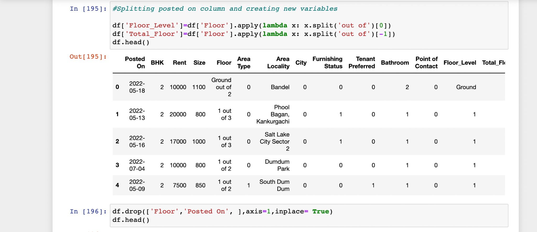

**Fig. 13** Split the floor-level variable

We renamed the columns and prepared the final cleaned data set.

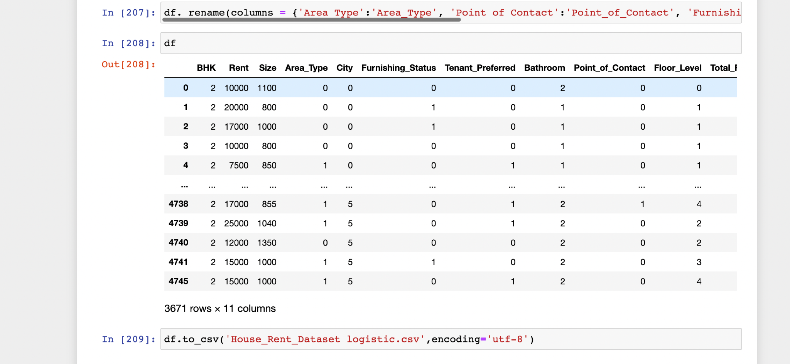

**Fig. 14** Data clean and ready for use

1. **Data Analysis and Data Visualization**

After data cleaning, we used a heat map to ensure there were no null values in the dataset, and the heat map visualization showed that there was no null value in our dataset.

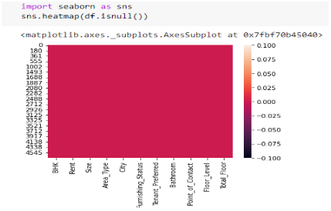

**Fig. 14** Heat map verifying no null values

We used box and whisker plots to show visual representation depicting groups of numerical data through their quartiles. Boxplot is also used for detecting the outlier in the data set. The Rent and Size box plots showed that there were many n outliers in the dataset that had to be eliminated for the accuracy of the data. To improve the accuracy of our model, we removed the outliers that were more than two standard deviations from the mean in the 'Rent' and 'Size' columns.

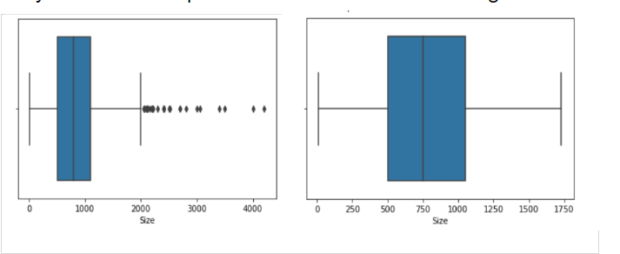

**Fig. 15** Before and afterbox and whisker plots of the "Size" variable

We used histograms for Size and Rent to show the distribution in the dataset. The data was normally distributed in both of these histograms.

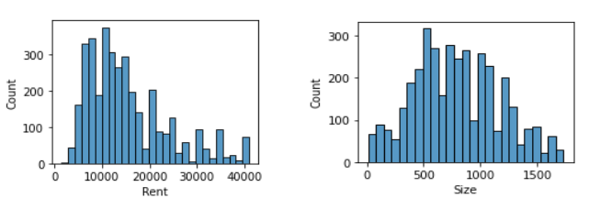

**Fig. 16** Histogram to visualize the distribution of the rent and size categories

Histograms were used to show the data frequency distribution for BHK, Furnishing status, Size, Bathroom, Total floor, Floor level, Area type, Point of contact, and Tenant preferred. We made a dictionary to assign a digital number to each variable.

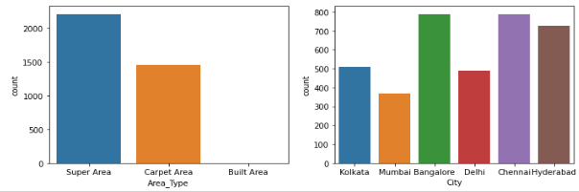

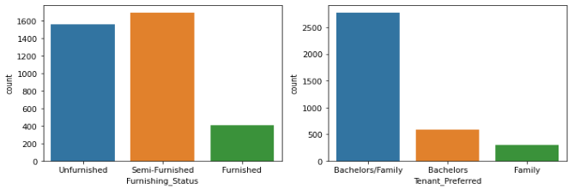

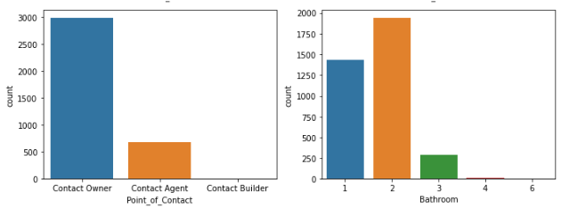

**Fig. 16** Histogram to visualize the distribution of independent variables

According to the histogram, we saw that the super area frequency was about 2200, the carpet area frequency was 1400, and the built area was about 0. City histogram showed 500 for Kolkata, about 380 for Mumbai, 790 for Bangalore, 500 for Delhi, 790 for Chennai, and 750 for Hyderabad. The histogram showed that the count of the unfurnished area is 1600 in the whole dataset, semi-furnished is about 1700 and furnished frequency is about 400. In tenant preference, the frequency for both bachelors and families is about 2800, for bachelors 500 and family about 200.

According to the histogram, we can see that the contact owner frequency is 3000, the contact agent frequency is about 700, and the contact builder frequency is 0. The frequency for one bathroom is about 1400, two bathrooms are about 1900, three is about 300, four is less than 50, and six is 0.

Pie Charts were used in our project to illustrate numerical proportions.

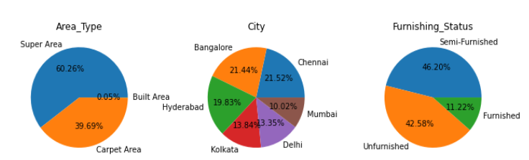

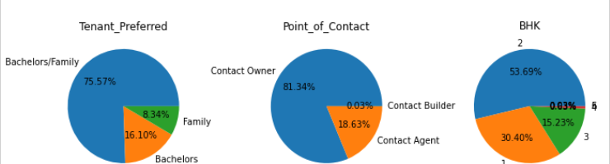

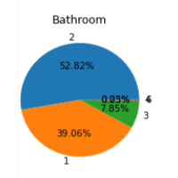

**Fig. 17** Pie charts were used to illustrate the numerical proportion of each variable.

**5.1 Correlation Among Attributes**

To understand the correlation between the variables, we built a correlation matrix using the following code:

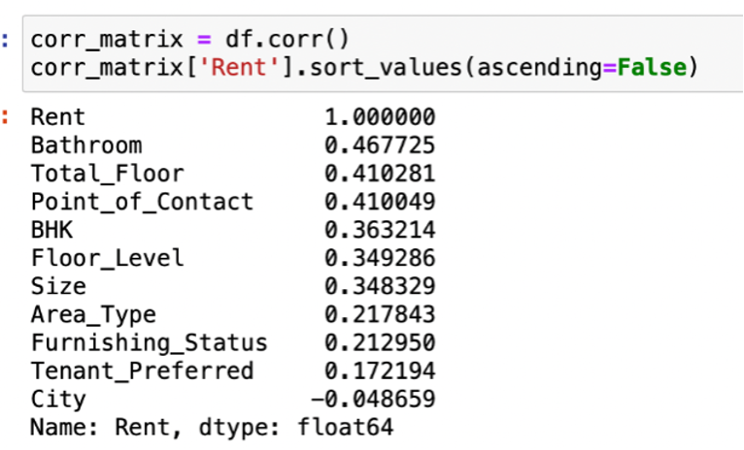

**Fig. 18** Code used to build correlation matrix

The independent variables have shown less correlation with Rent, and the variable, i.e., City, is negatively correlated. This means there is a significantly less correlation between the independent variables for predicting the dependent variable. The strongest correlation has resulted between Rent and Bathroom.

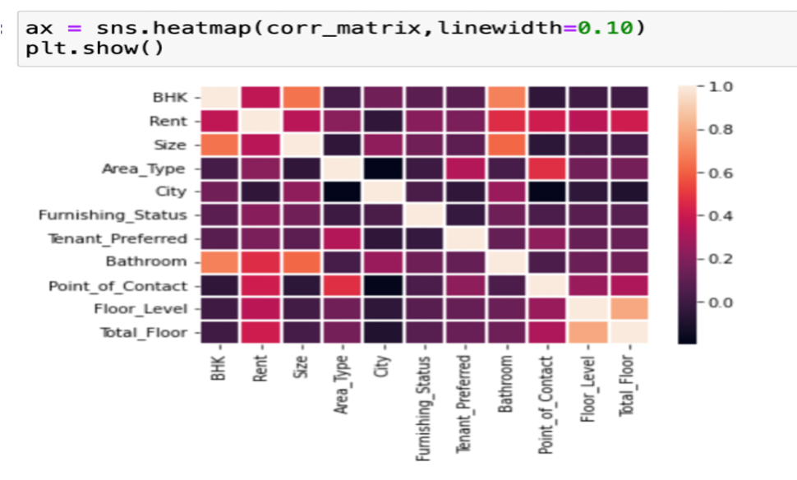

**Fig. 19** Correlation matrix including all variables

The heatmap plots the correlation between each of the variables. The scales show the correlation where darker color means no correlation and vice versa.

The heat map shows no significant correlation between Rent and these variables:

* Area_Type
* Furnishing_Status
* Tenant_Preferred
* City

**5.2 ANOVA Test**

Our group performed an ANOVA test to determine which of the independent variables (i.e., BHK, Size, Bathroom, City, Point of Contact, Furnishing Status, Tenant Preferred, and Area Type) most influence the dependent variable (Rent). Initially, we struggled to properly format the ANOVA test (Appendix A). In researching this topic, we found that we needed to use a one-way ANOVA test with Rent as our dependent variable. The ANOVA test helped us to determine whether there was a statistically significant difference in means when comparing variables.

We used the following Python code to build the ANOVA test:

import statsmodels.api as sm

from statsmodels.formula.api import ols

model = ols('Rent ~ C(BHK) + C(Size) + C(Bathroom) + C(City) + C(Point_of_Contact) + C(Furnishing_Status) + C(Tenant_Preferred) + C(Area_Type)', data=df).fit()

sm.stats.anova_lm(model, typ=2)

The results show all variables fall well below alpha (p <0.05), indicating that each variable plays a role in influencing the cost of Rent.

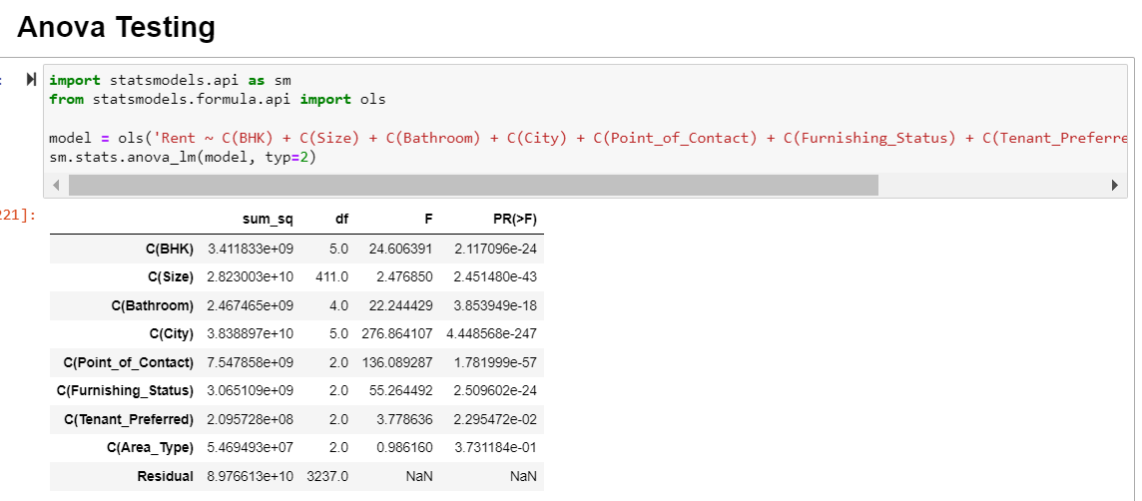

**Fig. 20** The above graph denotes the results of the ANOVA test

**5.3 Linear Regression Model**

We used a multiple linear regression machine learning model to understand the relationship between a single dependent continuous variable, i.e., Rent, and the other independent variable, i.e., Bathroom, Total_Floor, Point_of_contact, BHK, Floor_type, Size, etc.

Based on the heatmap mentioned above, we decided to drop the independent variables "Area_Type, Furnishing_Status, Tenant_Preferred, and City," keeping the rest for the development of the multiple linear regression model.

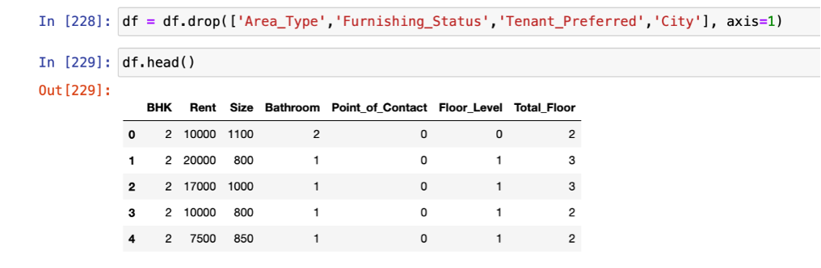

**Fig. 21** Drop the independent variables “Area_Type, Furnishing_Status, Tenant_Preferred, and City”

**Step 1:** We considered the dependent variable y = rent and x = all other variables by dropping Rent.

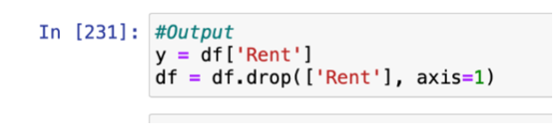

**Fig. 22** Define X and Y variables

**Step 2**: We developed seven models considering various independent variables to check which variable would contribute to the prediction of Rent.

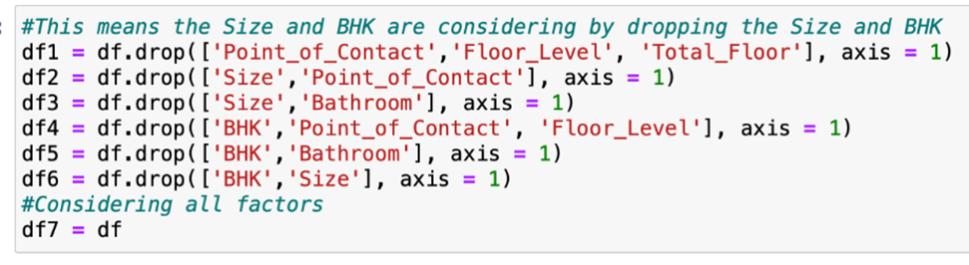

**Fig. 23** Developed seven different models using a combination of different variables

**Step 3:** We split the dataset into training and test sets by importing the train test split from Sklearn.model_selection. We considered 80% data in the training set and 20% data in the test set and randomly split the data (random_state=21)

**Step 4:** By importing the linear regression model through sklearn. We will now fit our regression model into the training set. After fitting the model using training

**Step 5:** We tested the model's performance with the test dataset.

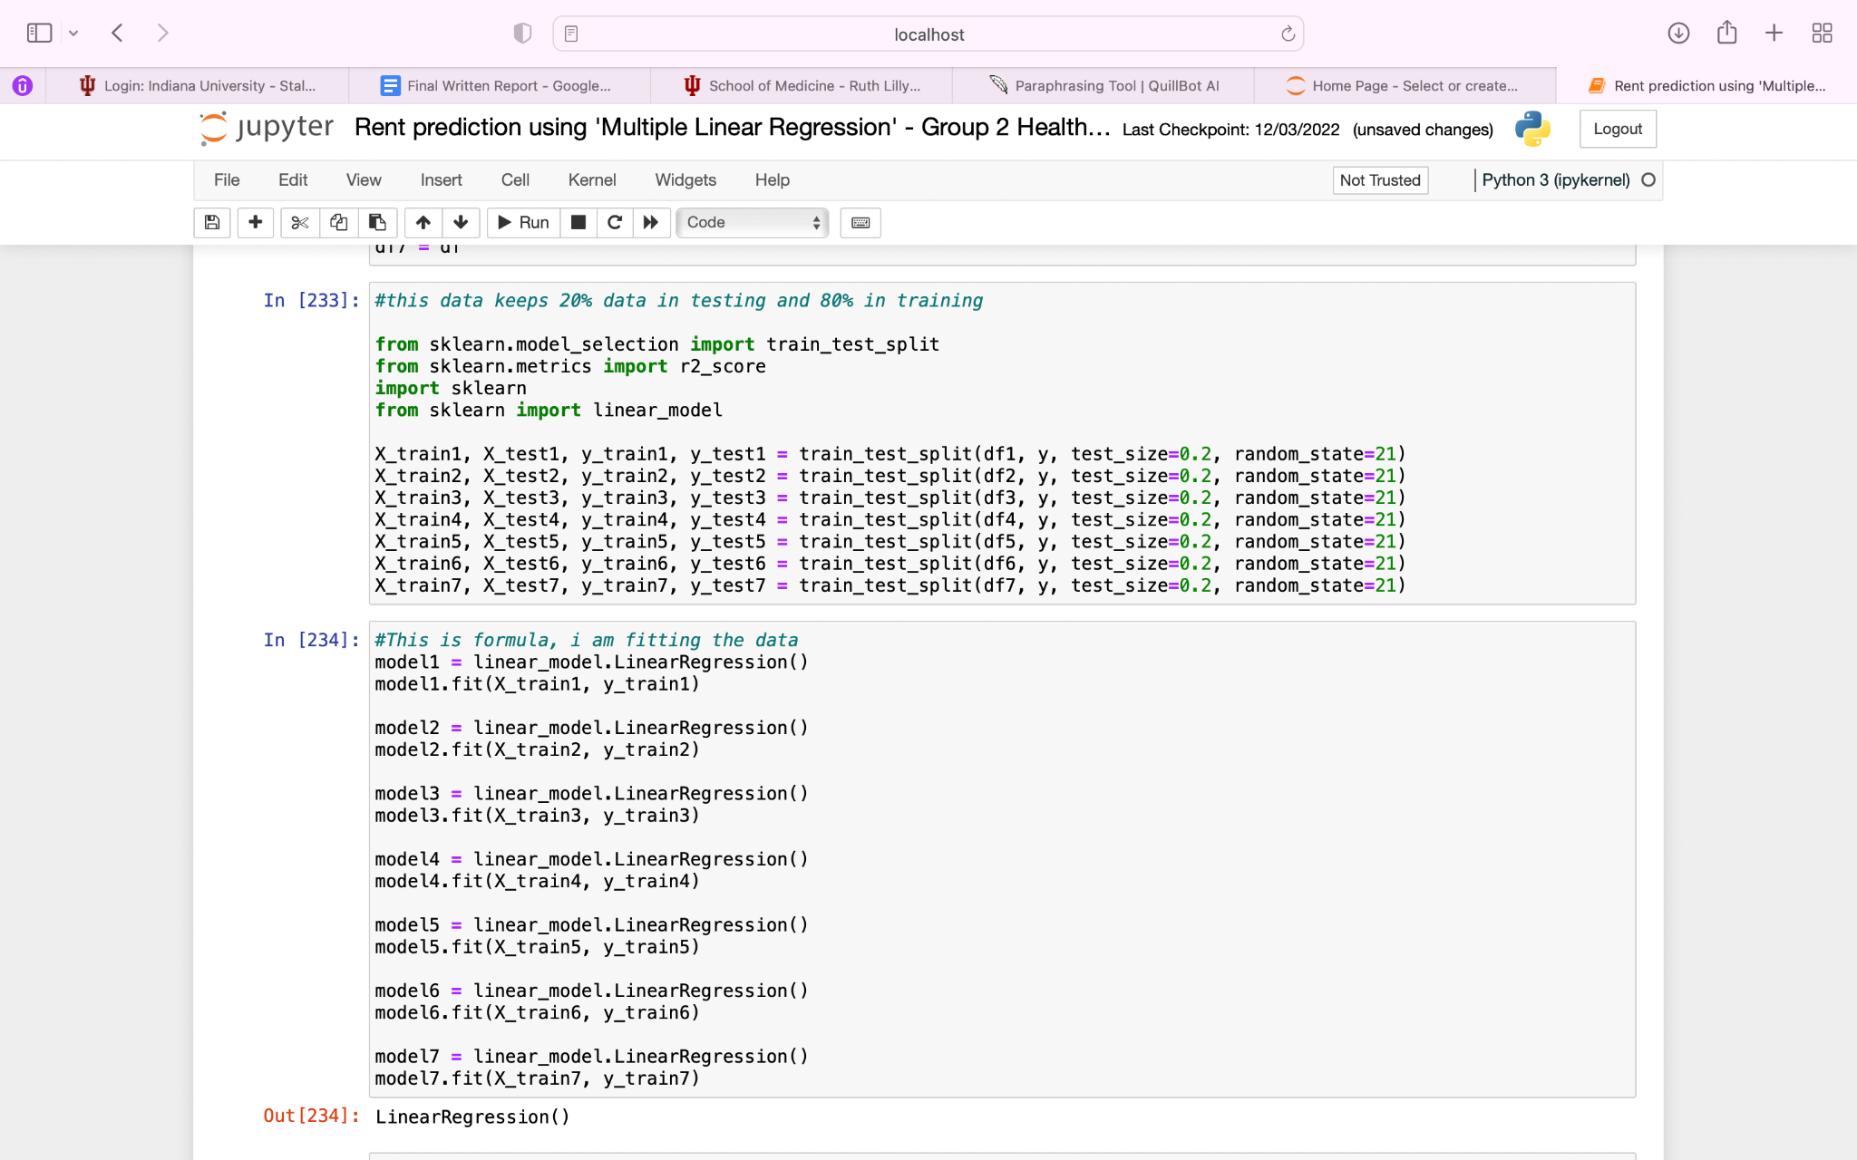

**Fig. 24** Training and test sets for all seven models

**Note:** To develop the model, we imported the **LinearRegression** class of the **linear_model** library from the **scikit learn**. We used the **fit()** method to fit our Regression model object to the training set.

**Evaluation of the Linear Regression model:**

We performed an **R-Squared Test (Coefficient of determination)** to understand the performance of the model developed. The value for R-squared can range from 0 to 1.

* A value of 0 indicates that the response variable cannot be explained by the predictor variable at all
* A value of 1 indicates that the response variable can be perfectly explained without error by the predictor variables.

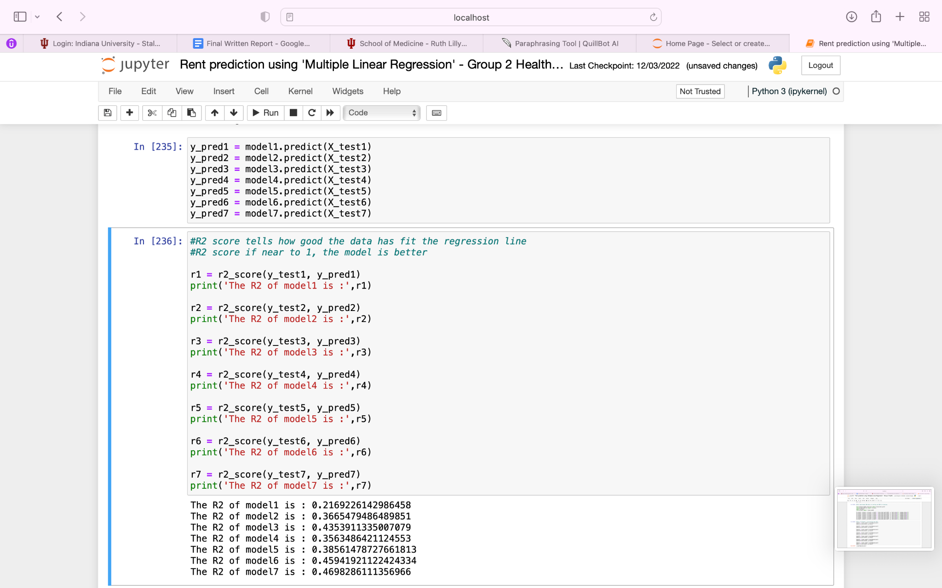

**Fig. 25** Results from R-squared evaluation

We found that the df7 model R- squared value is 0.46. These results suggest the model cannot precisely predict the accurate Rent of the house if provided the independent variables.

**Prediction using model df7**:

We provided an input of variables to predict the Rent of 2BHK, having an 1100 Sq Ft area and 2 Bathrooms. The point of contact for the house will be the owner, and the renter will be on the 1st floor of 2 story building. The predicted Rent was 16,106/- per month.

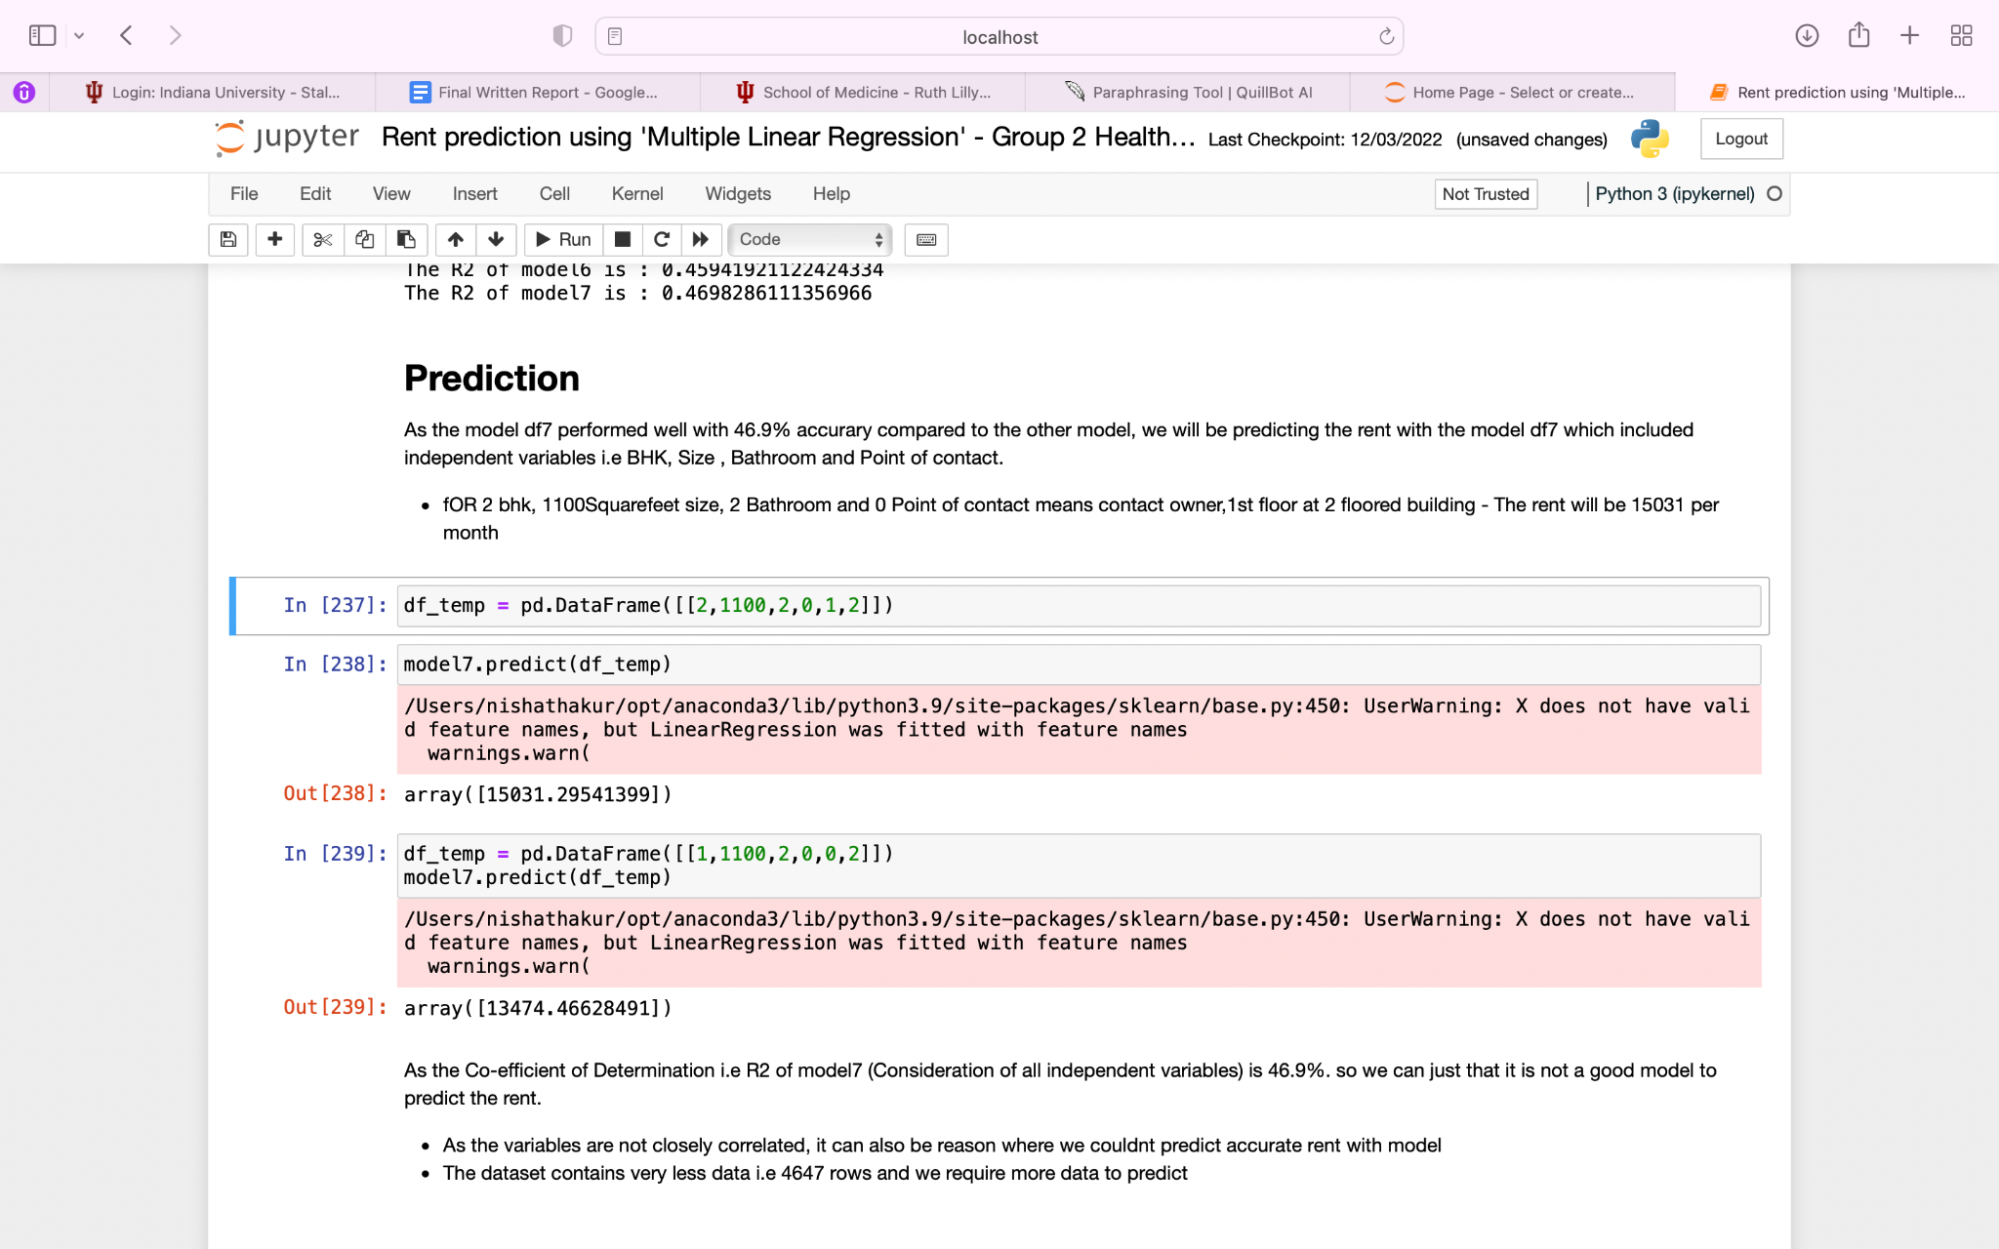

**Fig. 26** Results fromtest prediction

**5.4 Logistic Regression**

Our multiple linear regression model did not perform as well as was expected. As a result, we opted to categorize the rent values to build a logistic regression model. We split the "Rent" category equally into eight different groups. The groups were numbered 1 - 8 and renamed "Rent_Group."

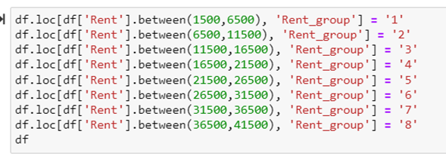

**Fig. 27** The following code was used to categorize the rent category

**Step 1:** We assigned X and y variables accordingly. Rent_Group serves as the dependent variable, while the remaining factors serve as independent variables.



**Fig. 28** Define X and Y variables

**Step 2:** We fit one logistic regression model using all the factors to predict the cost of Rent. We built this model as a trial to determine whether logistic regression could predict Rent more accurately than linear regression.

**Step 3:** We used the same approach as linear regression to split the data into training and test sets.

**Step 4:** We imported LogisticRegression from sklearn.linear_model and built the following model:

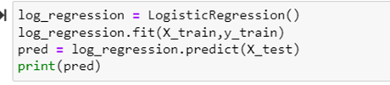

**Fig. 29** Logistic Regression model

**Step 5:** We ran a test prediction to evaluate the results. We asked the model to predict the cost of Rent for a two-bedroom, two-bath, 800 sq ft. apartment [area type = 1, furnishing status = 1, tenant preferred = 1, point of contact = 0, and City = 1]. The model predicted the cost of this home would fall into rent group 3, between 11,500 and 16,500 R per month.

**Step 6:** To evaluate the model, we tested the accuracy score using the following code:

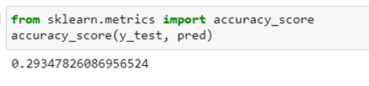

**Fig. 30** Logistic Regression model accuracy score

The logistic regression model performed poorly, with a 29% accuracy score. Therefore, we opted to keep the multiple linear regression model as our final choice.

1. **Data Visualization**

Our group created a variety of graphs to help visualize the data as referenced above. Graphs include histograms, pie charts, bar graphs, scatter plots, box and whisker plots, and heat maps.

Using Seaborn, the group created the following pair plot to help visualize paired relationships within the data.

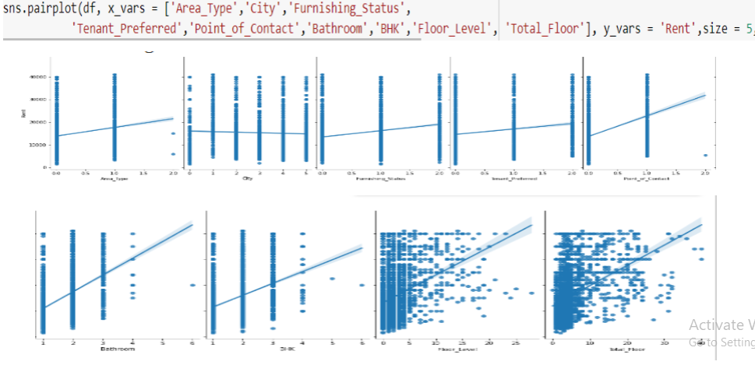

**Fig. 31** Pair plots of the individual variables created using Seaborn

1. **Summary of Findings**

We learned a lot about our study question after applying our methods for data cleaning, data analysis, and data visualization. Listed below are some of our main conclusions by research question.

The study inquiry is " Can we predict the Rent of houses in different cities in India using a multiple linear regression model that considers parameters like BHK, Size, Area Type, furnishings, City, Tenant choice, Point of contact, and No of bathrooms?"

The results are as follows: We examined the dataset for null values after shaping, duplicating, and characterizing it. The heat map is then displayed for non-null values.

To identify outliers, we utilized a box plot. The link between variables was represented using histograms, pair plots, and pie charts.

A correlation matrix was created to determine the relationship between the independent factors and the dependent variable.

Highest to Lowest correlation: Rent, bathroom, total floor, point of contact, bedroom, floor level, area type, furnishing status, tenant preference, and City. Variables with little association have been removed.

The accuracy of our logistic regression models, which we also constructed, is 0.29, while the accuracy of our linear regression models is 0.46. Despite their good performance, we could not accurately forecast the cost of Rent using these particular factors.

1. **Limitations**

While we tried to do our best in this project to control limitations, there were some limitations in this project, as with any other project.

The first limitation of our project was that none of us are domain experts in the real estate field, and we don't have a deep insight into real estate. This lack of experience and information may cause some critical information or research questions that we missed in our analysis.

The second limitation that caused many challenges for the team was that this was the first project for all team members. We all had limited Python and data science skills, and we were not as effective as someone who has worked in this industry for years.

**Appendix A**

Our group struggled to correctly code the ANOVA test. Using a colon in the code, we received an error stating the BHK data was "not a number." Corrections were made to alleviate this problem.

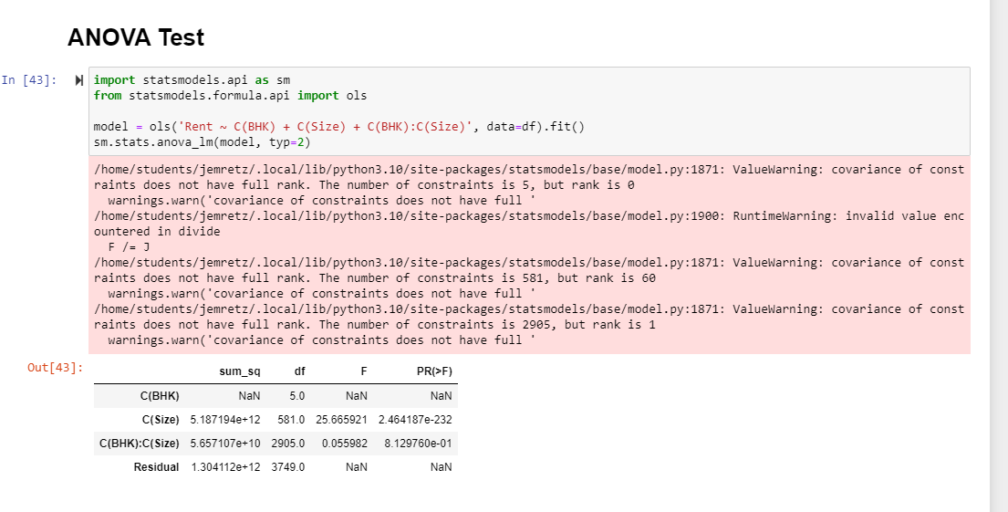

**Fig. 32** Erroneous code used in the ANOVA test

**References**

1. Banerjee, S: House Rent Prediction Dataset: https://www.kaggle.com/datasets/iamsouravbanerjee/house-rent-prediction-dataset. (2022)

2. Roy, A.: India's RBI Delivers Half-Point Hike to Rein in Inflation:

https://www.bloomberg.com/news/articles/2022-09-30/india-s-rbi-delivers-half-point-hike-to-rein-in-inflation-rupee?leadSource=uverify%20wall. (2022)

3. Sreevatsan, A.: Only 28% of Urban India lives in rented houses: Economic Survey: https://www.livemint.com/Politics/ixPbHQK7HGSOpUnoZnu7lO/Only-28-of-Urban-India-lives-in-rented-houses-Economic-Sur.html (2018)

4. Thakur, P.: Indian Rental Housing: A Complicated Asset Class: Anuj Puri, https://www.anujpuri.com/indian-rental. (2020)